Spring Beans :
A Spring Bean is an object that is instantiated, configured, and managed by the Spring IoC (Inversion of Control) Container.
In a normal Java program, developers manually create objects using the new keyword.

But in Spring Framework, objects are created and managed by the Spring IoC Container, not by the developer.
What the IoC Container does with Beans
The Spring container performs three main operations:
- Instantiation – Creating the object.
- Configuration – Injecting dependencies and setting properties.
- Management – Managing the lifecycle of the object.
Defining Beans in Spring
Spring provides three ways to define beans.

1. XML Based Configuration
Definition
XML-based configuration is a traditional method of defining Spring beans using an XML file where the bean class, properties, and dependencies are declared.
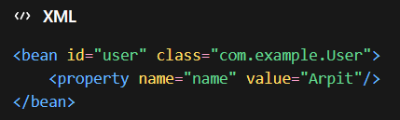
Spring reads the XML configuration file and creates the objects accordingly
2. Annotation Based Configuration
Annotation-based configuration is a modern approach in Spring where annotations are used directly in the class to define and manage beans.
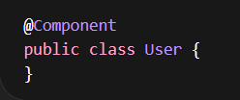
When Spring scans the package, it automatically detects classes marked with @Component and registers them as beans in the container.
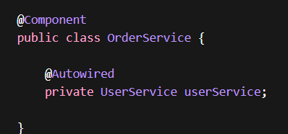h
Here spring automatically injects the user service dependency
3. Java Based Configuration
Java-based configuration is a way of defining Spring beans using Java classes and methods instead of XML.
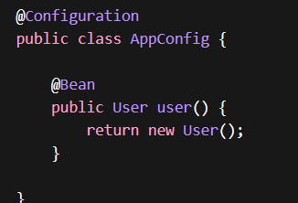
Spring Bean Scopes
Bean Scope defines the lifecycle and visibility of a bean instance in the Spring container, meaning how many instances of the bean will be created.

@Component
@Scope("singleton")
public class UserService {
}
Behavior
getBean() → same object
getBean() → same object
getBean() → same object
2. Prototype Scope
Prototype scope means that a new instance of the bean is created every time it is requested from the Spring container.
@Component
@Scope("prototype")
public class User {
}
Behavior
getBean() → New Object
getBean() → New Object
getBean() → New Object
Spring creates a fresh object each time the bean is requested.
3. Request Scope
Request scope means that a new bean instance is created for each HTTP request in a web application.
@Component
@Scope(value = WebApplicationContext.SCOPE_REQUEST)
public class RequestBean {
}
Behavior
HTTP Request 1 → Bean 1
HTTP Request 2 → Bean 2
HTTP Request 3 → Bean 3
The bean exists only during the lifecycle of the HTTP request.
4. Session Scope

Session scope means that a single bean instance is created and shared for the entire HTTP session of a user.

@Component
@Scope(value = WebApplicationContext.SCOPE_SESSION)
public class SessionBean {
}
User Login → Session Created
Same bean used for entire session
Each user session gets its own bean instance.

5. Application Scope
Application scope means that a single bean instance is created for the entire web application and shared across all users and requests.
@Component
@Scope(value = WebApplicationContext.SCOPE_APPLICATION)
public class AppBean {
}
Key Point

- Horizontal Scaling
Horizontal Scaling is the process of adding more servers or machines to distribute the load instead of increasing the power of a single server.
Explanation
Instead of upgrading one powerful server, multiple servers handle requests in parallel.
Example:
User Requests
↓
Server 1
Server 2
Server 3
Key Idea
More machines → More capacity → Better fault tolerance.
Request Type
✔ Mostly Synchronous
Client sends request → one of the servers processes it immediately.

2. Load Balancer
A Load Balancer is a component that distributes incoming client requests across multiple servers to ensure no single server becomes overloaded.
It sits between clients and servers.
Client Request
↓
Load Balancer
↓ ↓ ↓
Server1 Server2 Server3
Benefits
- Prevents server overload
- Improves availability
- Improves response time
Request Type
✔ Synchronous
Request is immediately routed to one server which returns the response.

3. Database Sharding
Database Sharding is a technique of splitting a large database into smaller independent databases called shards to distribute data across multiple servers.
Example:
Users Table
---------
Shard 1 → Users 1–1000
Shard 2 → Users 1001–2000
Shard 3 → Users 2001–3000
Benefits
- Handles very large datasets
- Improves database performance
- Enables horizontal database scaling
Request Type
✔ Mostly Synchronous
Application directly queries the appropriate shard and returns the response.

4. Caching
Caching is the process of storing frequently accessed data in a fast storage layer (cache) so future requests can be served faster
Client Request
↓
Cache (Redis / Memcached)
↓
Database (if cache miss)
Benefits
- Reduces database load
- Faster response time
- Improves system performance
Request Type
✔ Synchronous
Client request → cache lookup → response returned immediately.

5. Queues (Message Queues)
A Queue is a messaging system used to store and process tasks asynchronously by sending them to a queue and processing them later by worker services.
Explanation
Example:
User Request
↓
Message Queue
↓
Worker Service
↓
Process Task
- Email sending
- Image processing
- Background jobs
Benefits
- Decouples services
- Handles heavy workloads
- Enables background processing
Request Type
✔ Asynchronous
Client does not wait for processing to complete.

6. CDN (Content Delivery Network)
A CDN is a geographically distributed network of servers that deliver static content (images, videos, CSS, JS) from the server closest to the user.
User (India)
↓
Nearest CDN Server
↓
Content Delivered Faster
Benefits
- Faster content delivery
- Reduced latency
- Reduced load on origin server
Request Type
✔ Synchronous
User requests content → CDN immediately returns it.

7. Rate Limiter
A Rate Limiter is a mechanism used to control the number of requests a user or client can make to a system within a specific time period.
Limit: 100 requests per minute per user
If exceeded → request rejected.
Example response:
HTTP 429: Too Many Requests
Benefits
- Prevents system overload
- Protects APIs
- Prevents abuse or attacks
Request Type
✔ Synchronous
Rate check happens instantly before processing the request.

Concept | Definition | Request Type
Horizontal Scaling | Adding more servers to handle load | Synchronous
Load Balancer | Distributes requests across servers | Synchronous
Database Sharding | Splitting database into smaller parts | Synchronous
Caching | Storing frequently used data in fast storage | Synchronous
Queues | Process tasks in background using messaging | Asynchronous
CDN | Deliver content from nearest server location | Synchronous
Rate Limiter | Limits number of requests per user | Synchronous

